Marram Grass: Coastal resilience and implementing nature-based solutions in Portmarnock, Ireland

By: Naomi McCullagh

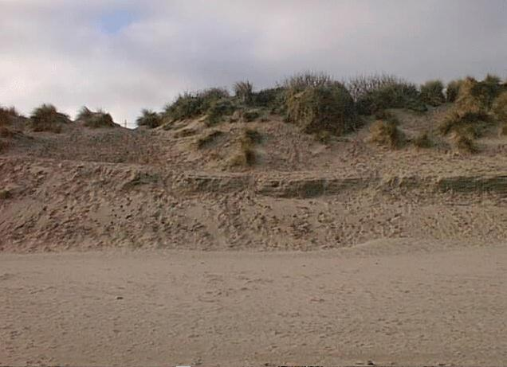
On Thursday the 5th of May a group of 30 students travelled down to Portmarnock beach, where we worked on our Marram grass project. We departed for the beach at 9:30am and arrived down to the sand dunes at 10:00am, where we started our Marram grass planting.

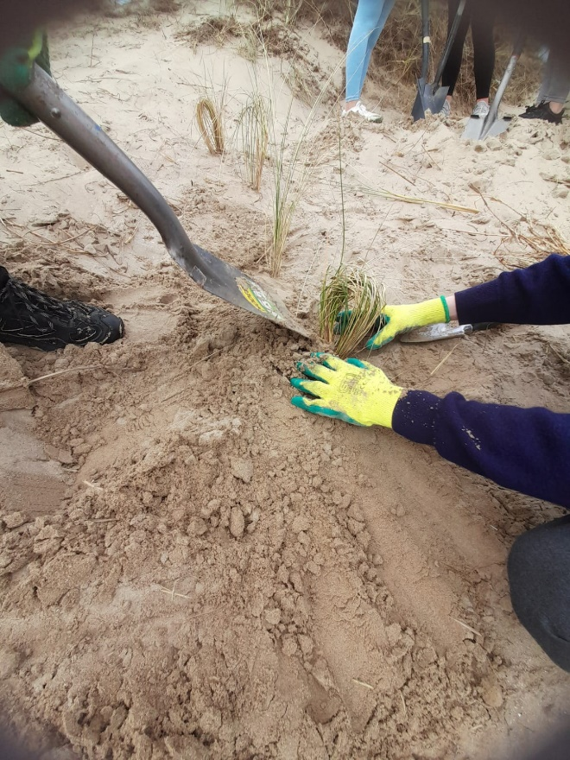
Our first task was to collect seaweed. We had to place it along a horizontal line running down a section of the beach, to help newly planted Lyme Grass (Leymus arenarius) grow. Once the whole line was completely covered with seaweed, we then started the Marram Grass planting process. In every group of three, there was one digger, one planter, and one organiser. We started at the top of each sand dune, and worked our way downwards in a straight line to let each sand dune grow correctly. The Marram grass was planted roughly twelve inches between each planting, to give the newly growing grass space to grow. We continued this process throughout the beach until we had completely planted the area provided to us. We planted a total of 120 clumps of Marram Grass.

Marram grass has been planted because sand dunes protect inland areas from swells, tides, and winds, so they must be protected, and stay damage free. The ocean and the wind can have an unpredictable, destructive force on coastal regions, which can harm these dunes if they are not secured properly, or replanted throughout the year.

Three classes of 4th year students from our school got involved in this process at the start of the year, when realising how much of a need there is for sand dunes in our society. The sand dunes in Portmarnock beach are beginning to collapse throughout time, which will soon have a devastating effect if they are not replanted regularly.

