An Choill Bheag
By Benamrane Nekrouf & Adam Sterio

As part of their PULCHRA project, students from Drimnagh Castle partnered with An Choil Beag.

An Choill beag is a long-term education program set up by LEAF Ireland.It’s a small and biodiverse woodland habitat on the school grounds which acts as outdoor classrooms for students to spend time learning outside Below, the students describe their experience planting a small woodland habitat on their school grounds.
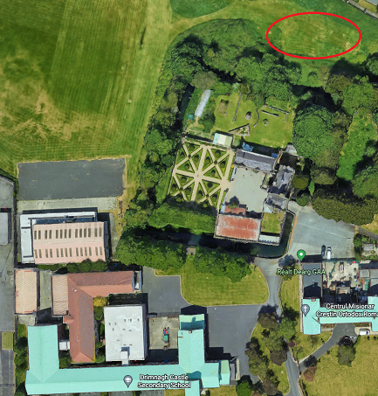
On Monday 24th January we had our guest Clare from An Taisce visit the school to talk to Mr Devilly,Ray the caretaker,and Ms Sattar about the outdoor classroom. They discussed the outdoor classrooms location,size and what type of trees would be planted. They decided to have the outdoor classroom somewhere in the field by the moat. They talked about planting 100 native deciduous tree saplings which once planted will grow into a forest over a few years.The outdoor classroom will have a rectangular area roughly about 10x10 meters with a semi-circular entrance. They also discussed having it a meter distance from everything to create a natural habitat.

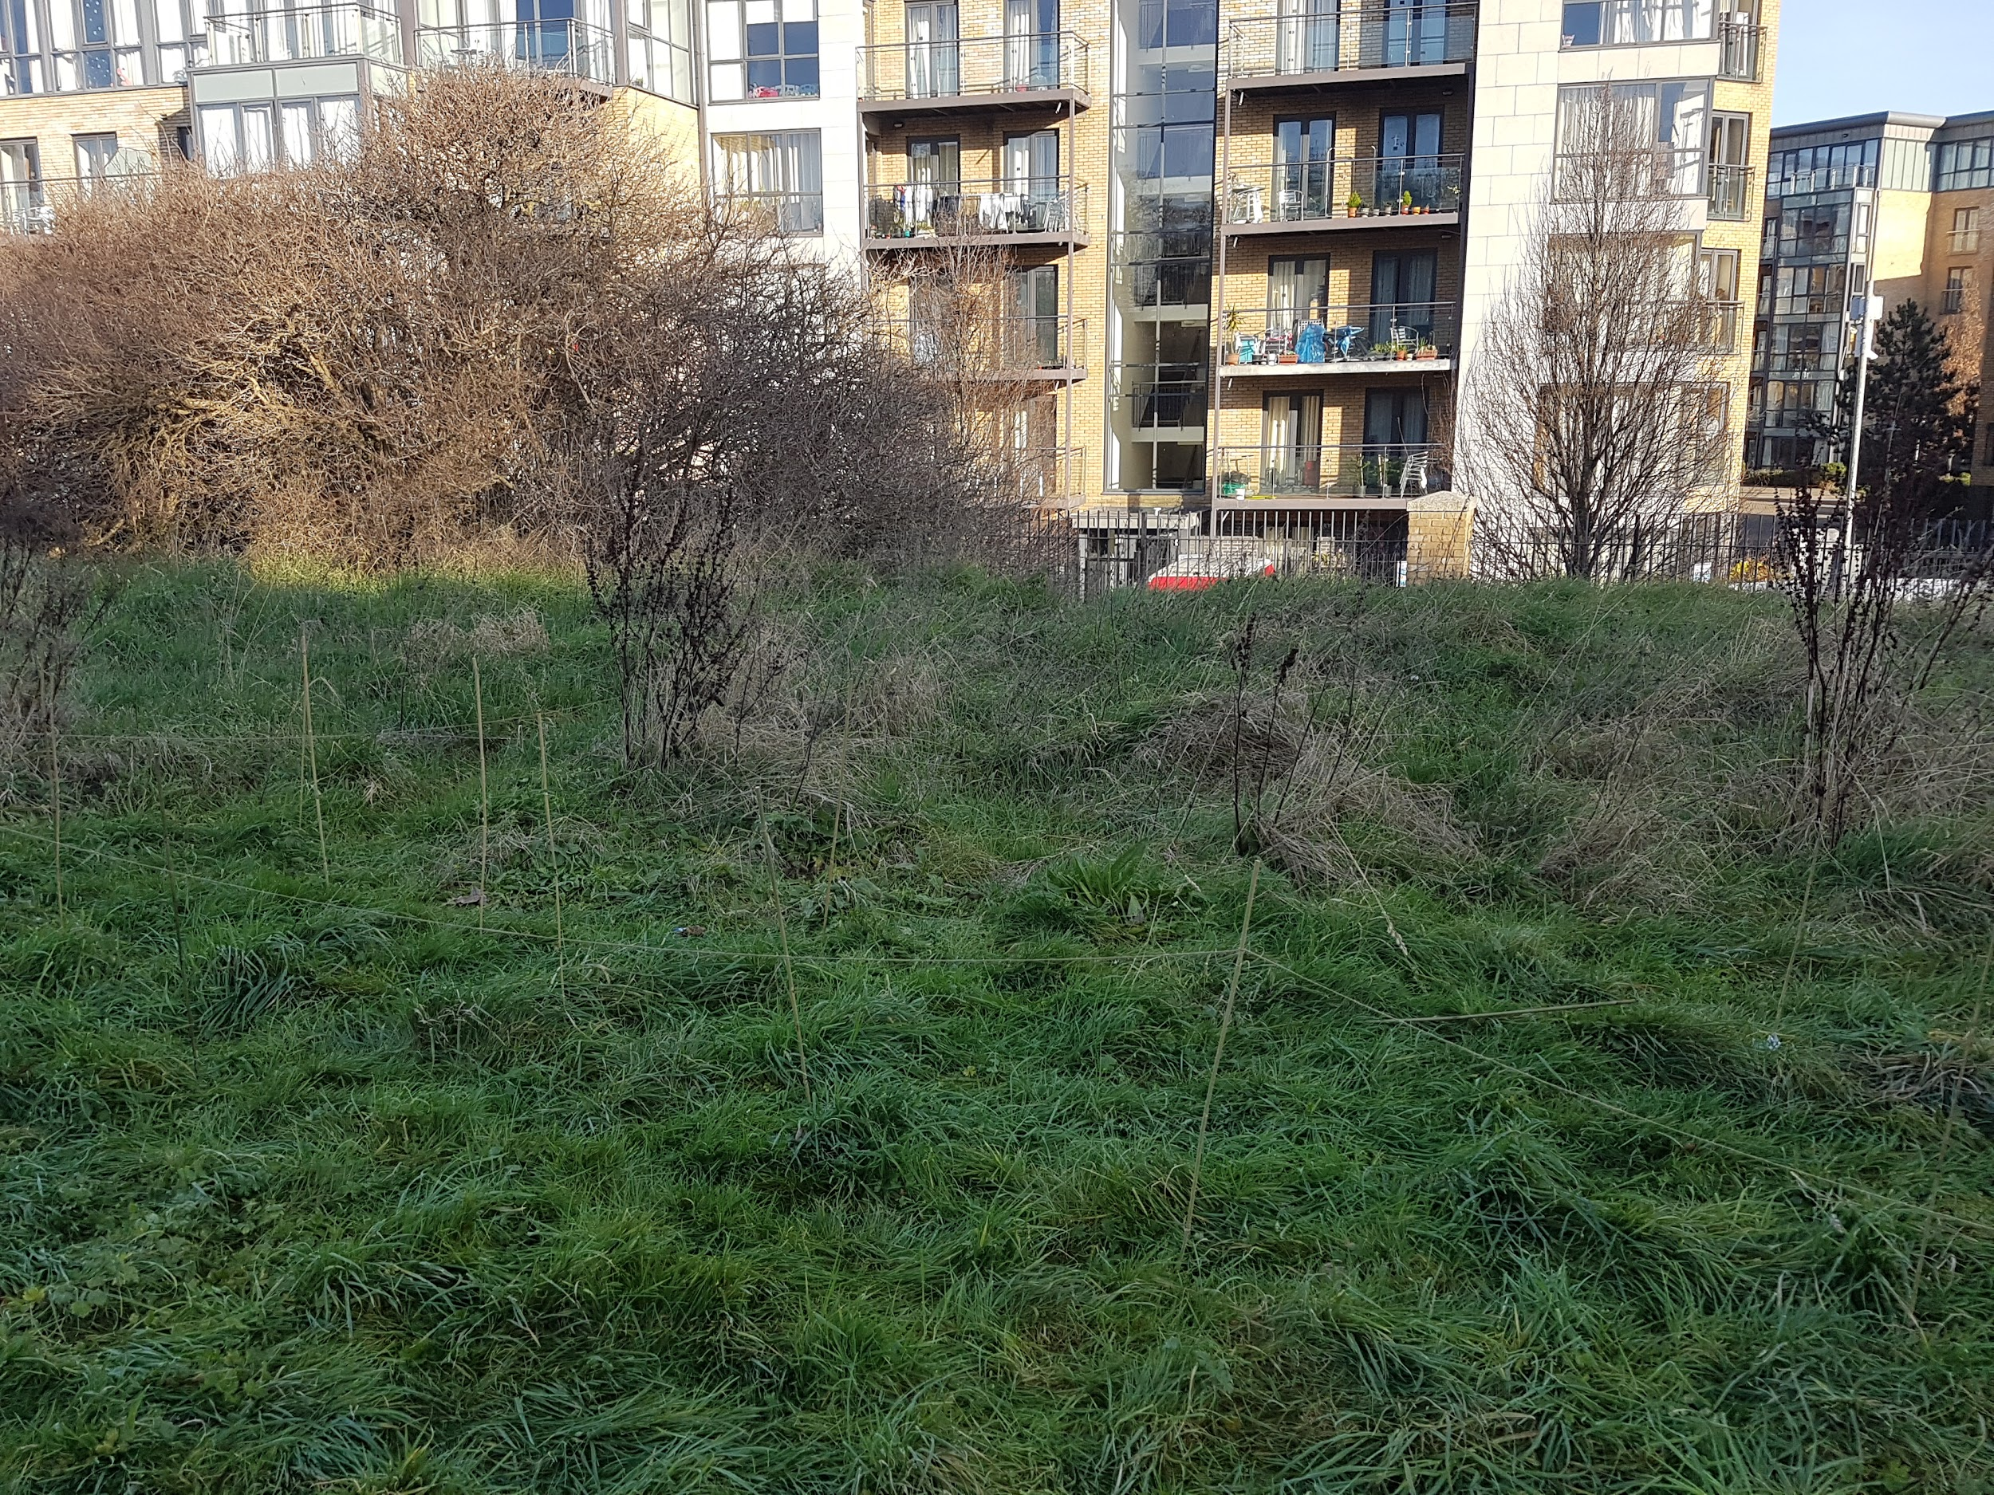
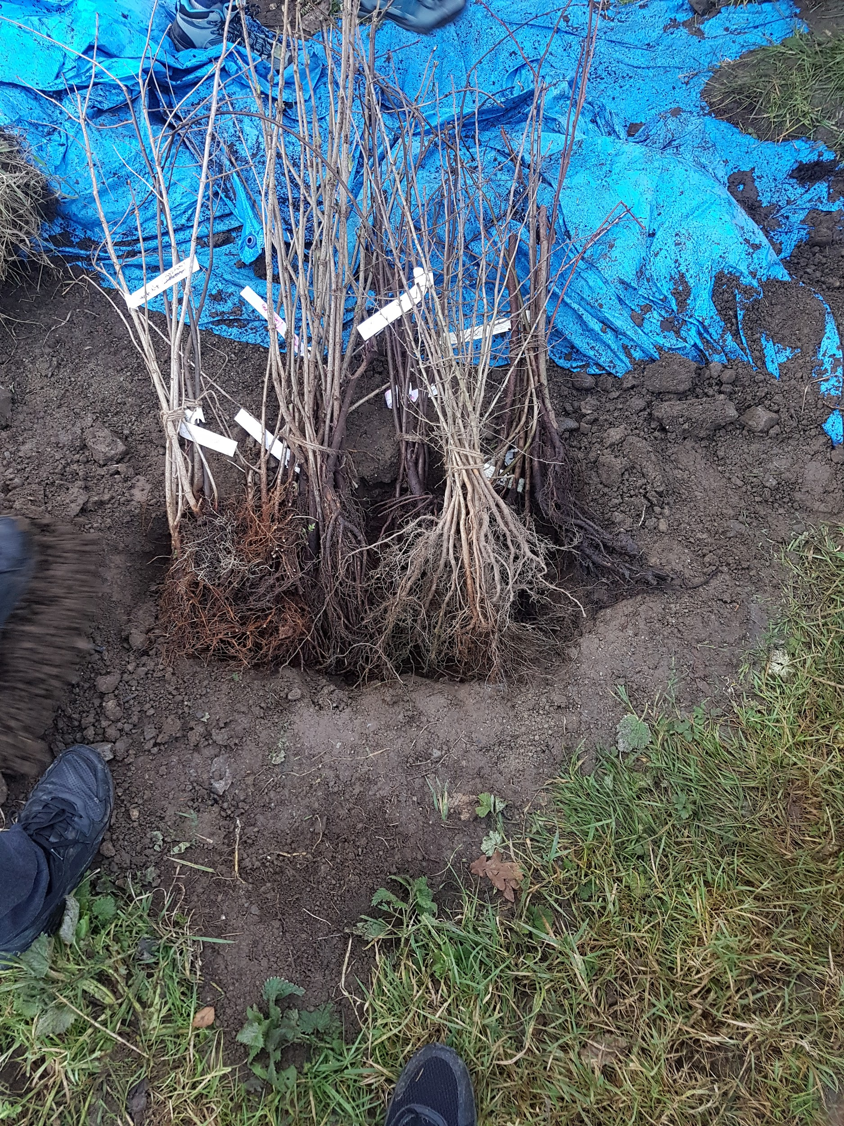
Later on Wednesday 26th of January the transition year classes met Clare, as she explained to them the different trees they will plant for the outdoor classroom. They dug a foot deep hole to leave the saplings in and they then went over to plot the area they’ll plant the trees in. They plotted out a 10x10 meter area with bamboo sticks and string. They were then paired up in groups of three and looked at the different plants and leaves with a pocket magnifying glass. They got back together and measured the soils pH level followed by the soils moisture level. Clare later explained that on March 14th she will hopefully be back to help us with the planting process.

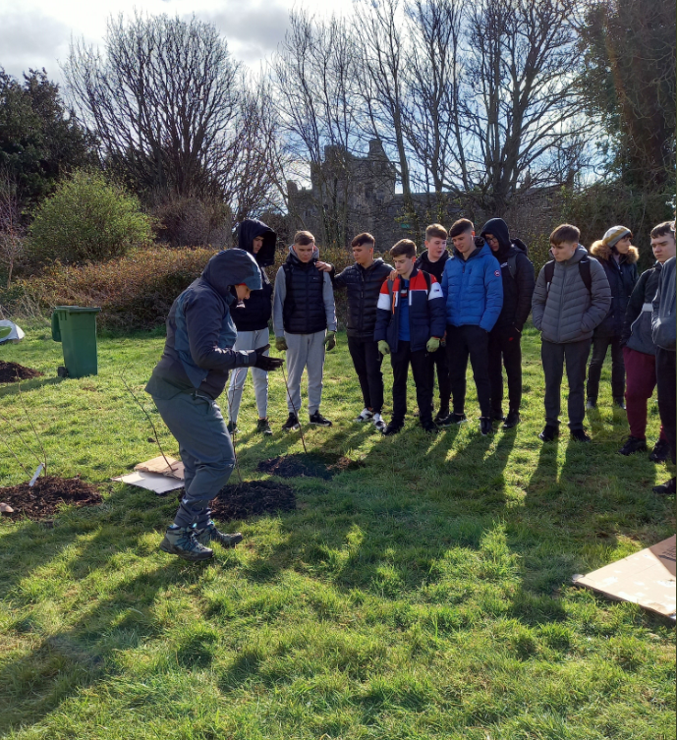
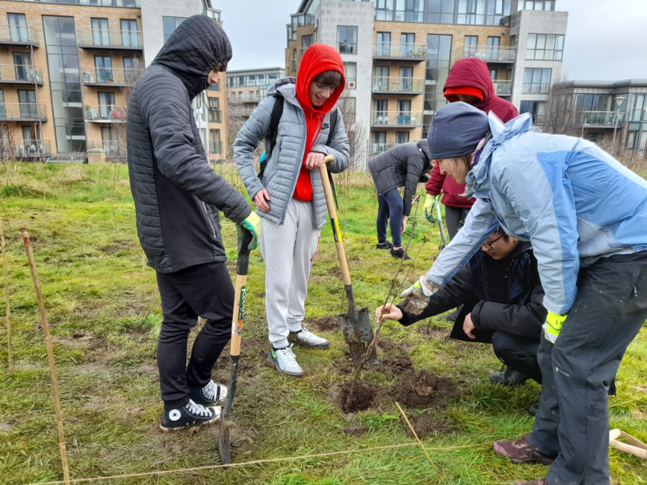
On Monday 14th March the transition years saw Clare once again and met her colleagues Maya and Aileen and they got the transition years to spit into groups for planting the trees. They dug holes and made sure there were no huge rocks and put the trees in. They then filled the holes with soil and when all the trees were planted, the transition years tore some cardboard and made some slits and placed them in with the trees and put on mulch afterward to prevent the grass from growing and suffocating the trees.

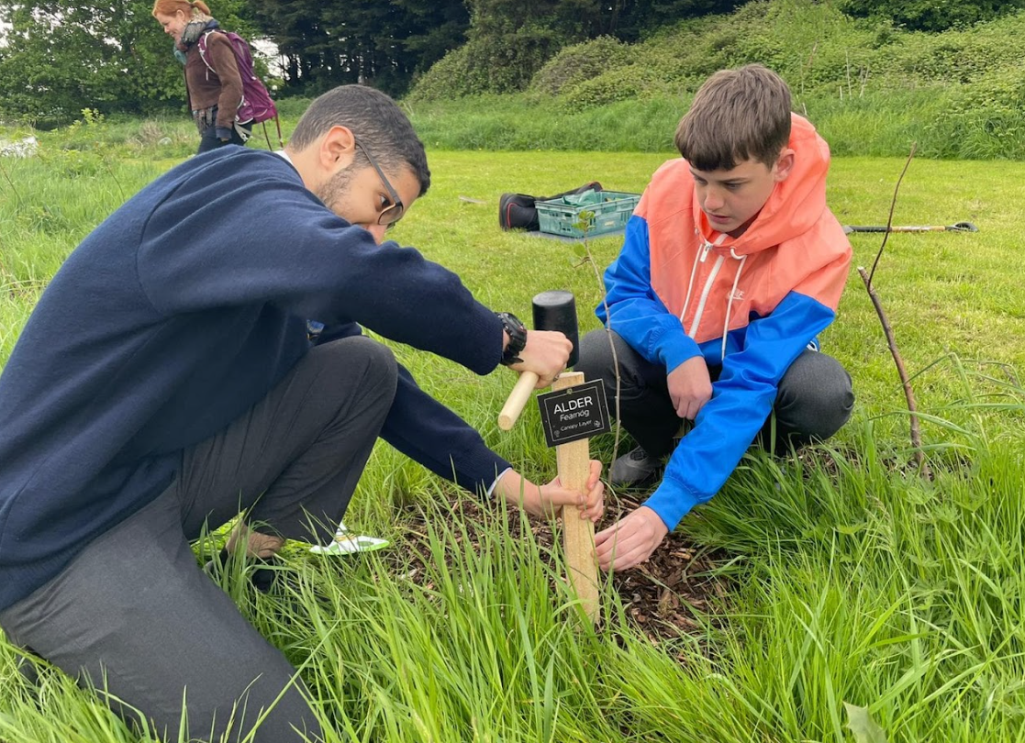
On Friday 13th May, the transition year classes once again met up again with Clare, Maya & Aileen to check up on the growth of the trees. They had also brought guests, they were representatives of KBI who are also sponsors. One member of KBI, Pat Cassels, is a former pupil of Drimnagh Castle Secondary. The transition years were given signs to label trees and a list to help identify them. They then all grouped up to talk with Clare, Maya and Aileen about the types of trees planted like spindel and elder. They also talked about the future of this project and about how important it is.There were also a few words from Pat and his colleague. The transition years were then given pocket magnifying glasses and were told to look under the mulch to see if there are any wildlife growing in the outdoor classroom. They found some slugs, worms, woodlice, and a spider with an egg sack. They were released back into the environment and they stepped on the grass to keep them away from the trees.



