Urban Water Quality – Project Guidelines

- Identify a local river/stream, preferably one that is within walking distance of your school
- Find your local river on the EPA Water Catchment website

Example: Water Catchment Website
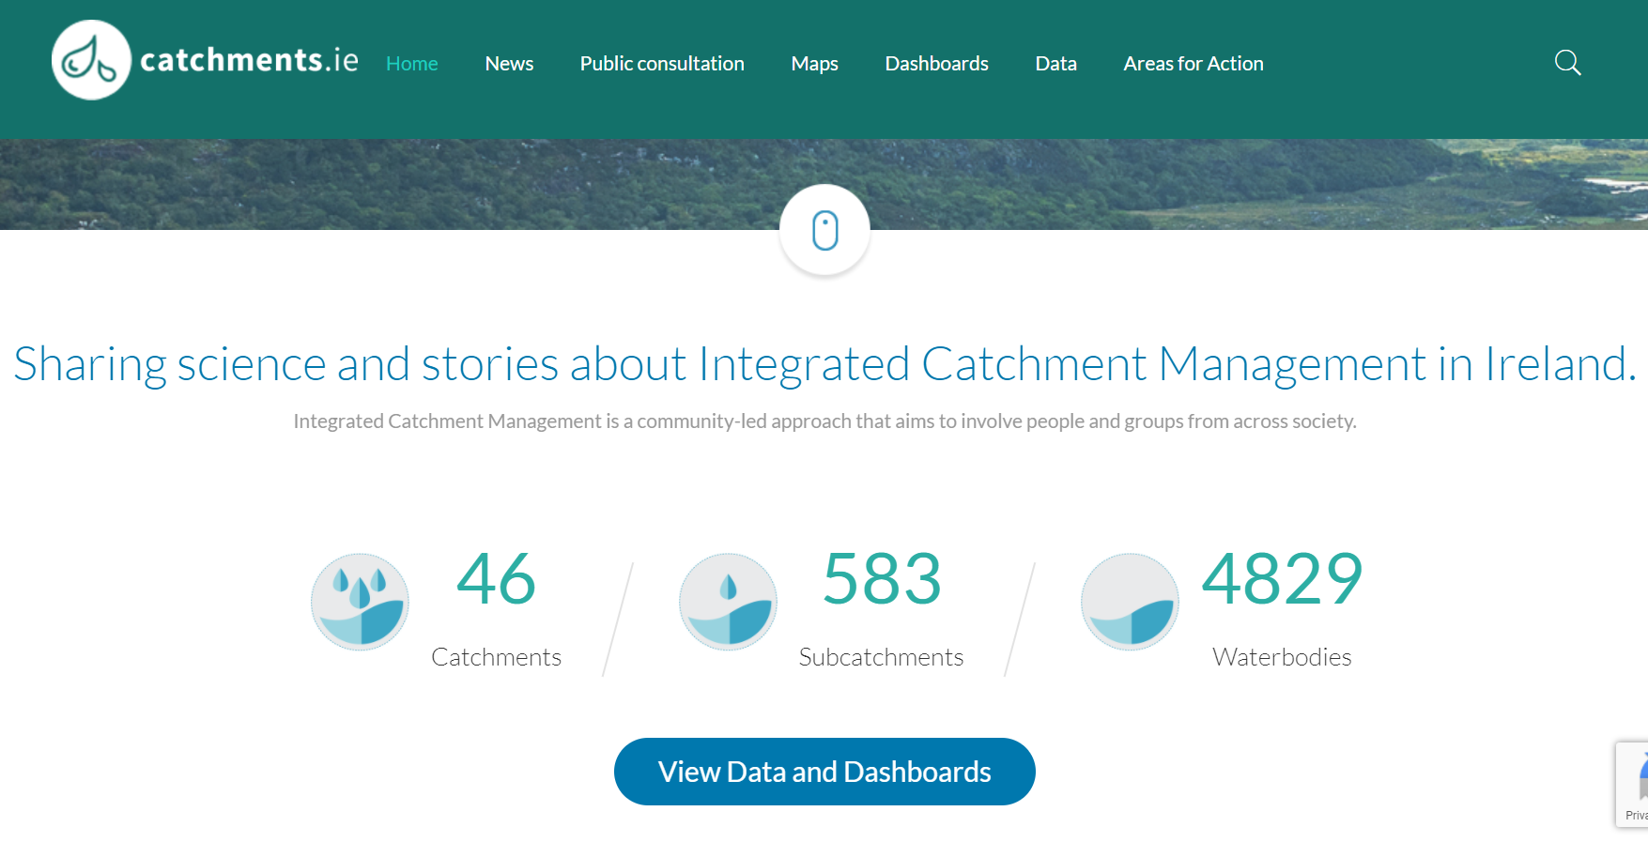
- Click on View Data and Dashboards
- Input your river name, for example Dodder

Results for Dodder showing layer ‘River Bodies Risk’
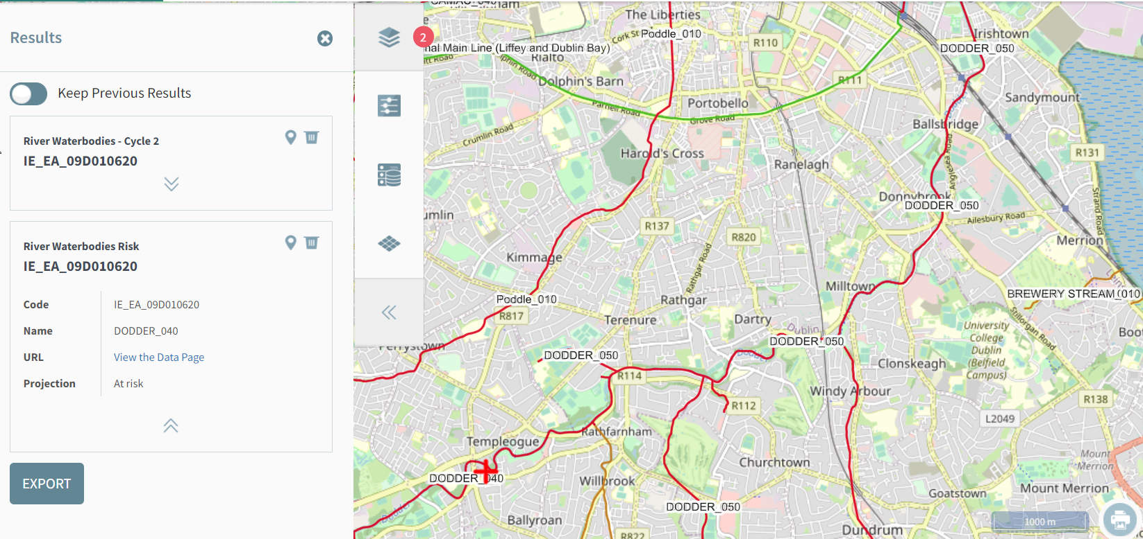
By searching the EPA catchment database, we can see that the lower stretches of the Dodder River are coloured red and are ‘At Risk’
You may notice that your local stream or river is ‘unassigned’ which means there is no data available to evaluate your river/stream. This is a problem as the pollution status is unknown and no action can be taken if a pollution problem exists.

- Desk Study
Ask students to look for information about their local river online, there are many reports and resources available for the larger rivers but not as much for smaller streams.
Complete the following table:
Name of River/Stream
Location of River Study Area
Source of river
Length from source to sea
Local Rock Type (see GSI Maps)
Is this river assigned ‘At Risk’

GSI Maps – Find your local rock type here
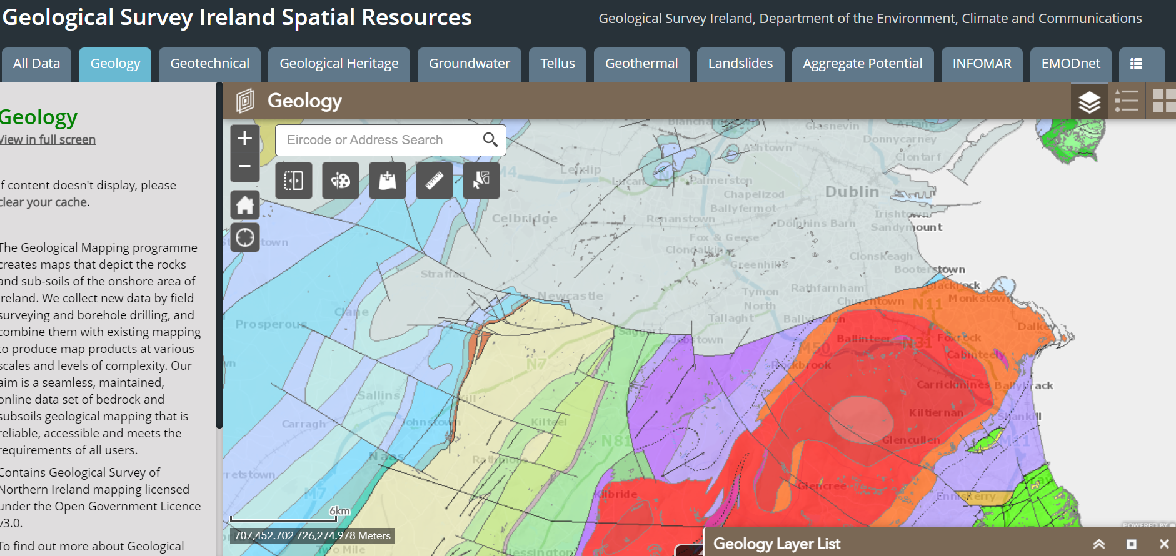
Click on map to find the rock type e.g., limestone, granite. The underlying rock type will influence the river water acidity.

- Visit your local river/stream
Complete a river survey sheet – get in touch with Aileen (abright@eeu.antaisce.org) for this and further information on river biodiversity studies.

