GLOBE: Air Quality Module

Take time to think about our Air Quality

Dear Teachers,
While Ireland’s overall air quality is generally good by international standards it is now apparent that local air quality may not be as consistently good. It is now considered that any level of air pollution is not acceptable and poses a risk (World Health Organisation -WHO). In this resource, you will find up-to-date information on air pollution, with a particular focus on Ireland.
According to the EEA (European Environmental Agency) Air Quality in Europe report, 2019, air pollution is currently the most important environmental risk to human health, and it is perceived as the second biggest environmental concern for Europeans, after climate change. As a result, there is growing political, media and public interest in air quality issues and increased public support for action.
The aim of this module is to introduce the topic of air quality and air pollution to students. It can be a standalone resource or can be used to introduce air quality to students as part of the GLOBE Air Quality Campaign.
The activities associated with this module are GLOBE Air Quality Campaign resources:
AQC2_Mapping
AQC3_Clouds
AQC4_Traffic Survey
AQC5_Topography

Engage Class:
Before researching information around air pollution, it is recommended to do a brainstorming session to gauge student knowledge and interest in the subject of air quality.
Brainstorming Activity: In small groups – take 5-10 minutes to brainstorm ideas and knowledge around our air.

Assign an aspect of air quality to each group

- Where does air pollution come from?
- What are the pollutants?
- Why do we care?
- What can we do about it?

Is Ireland’s Air Clean?
Watch: This is an excellent 24-minute Eco Eye programme on Ireland’s air quality and the challenges we face when tackling air pollution in Ireland. It provides a good general introduction to air pollution before exploring the discussion points below.
https://www.youtube.com/watch?v=e6rglsLy1Ys.

Now for some more background information!
Watch this National Geographic video in air pollution ‘Air Pollution 101’ here: https://www.youtube.com/watch?v=e6rglsLy1Ys

The UN Environment launched a new air pollution webpage on International Day of Clean Air (September 7th) , see: https://www.cleanairblueskies.org/.

The Sustainable Development Goals and Air Pollution
The Sustainable Development Goals (SDGs), are 17 broad goals, adopted by the UN Member States in 2015. They represent a universal ‘call to action’ to end poverty, protect the planet and improve lives everywhere. The topic of air pollution is addressed in the following SDGs.

Goal 3 – Good Health and Well-Being
Goal 3.9 By 2030, substantially reduce the number of deaths and illnesses from hazardous chemicals and air, water and soil pollution and contamination.
Pollution is recognised as one of the most serious threats to human health and our environment.

Goal 7 – Affordable and Clean Energy
3 billion people rely on wood, coal, charcoal or animal waste for cooking and heating
Goal 7.2 By 2030, increase substantially the share of renewable energy in the global energy mix
Clean energy is vital to reducing air pollution, both indoors and outdoors.
Goal 11 – Sustainable Cities and Communities
Rapid urbanization is exerting pressure on fresh water supplies, sewage, the living environment, and public health
Goal 11.6 By 2030, reduce the adverse per capita environmental impact of cities, including by paying special attention to air quality and municipal and other waste management
Air quality in urban environments is a growing concern. The GLOBE Air Quality campaign addresses the issue of traffic related air pollution which is a concern in our cities.
According to the UN: https://www.un.org/sustainabledevelopment/cities/
Half of humanity – 3.5 billion people – lives in cities today and 5 billion people are projected to live in cities by 2030.
By 2050 70 per cent of the world population is predicted to live in urban settlements.

Introduce your students to the ‘scientific method’
Ask students – what is the first step when conducting a scientific investigation?
The Scientific Process begins with observations!

What observations can your students make about air quality in Ireland?
Has any student observed air pollution or read about air quality in Ireland?
What would students like to know about air pollution in their local environment?

Air Pollution Information: Facts and Figures

- Where does air pollution come from?
In the broadest terms, there are natural (non-man-made) sources of pollution and man-made sources of pollution. Here are some examples of natural and man-made sources of air pollution. Can students think of more?

Man-made sources
Burning fossil fuels
Agriculture
Transport (land, air, and sea)
Industry
Waste (landfill)
Natural Sources
Volcanoes
Sea Salt
Sand
Organic material in air (plants)
Ozone (layer, not ground level)

- What are the main air pollutants?
Pollutants include tiny particles and gases that are harmful to human health.

- Particulate Matter Pollution
Particles are typically referred to as particulate matter (PM) and are classified based on their size, PM 2.5 are particles measuring less than 2.5 microns and PM 10 are particles measuring less than 10 microns. For reference, a human hair thickness is approximately 50-70 microns.
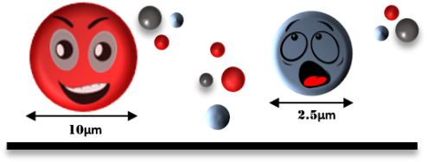
The size of a particle gives scientists clues about its origin and composition. Not all particles are the same. Larger particles tend to form when salt, sand, or ash is blown into the air by strong winds. Dust, pollen, and mold all form medium-sized particles, while the smallest particles come from combustion processes or chemical reactions.
Can we see the particle pollution?
The particles or PM are a mixture of solid particles and liquid droplets found in the air. Some particles such as sand, soot or smoke are large or dark enough to be seen with the naked eye. Others are so small they can only be detected using an electron microscope.

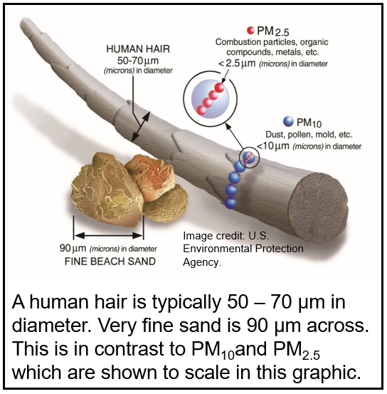

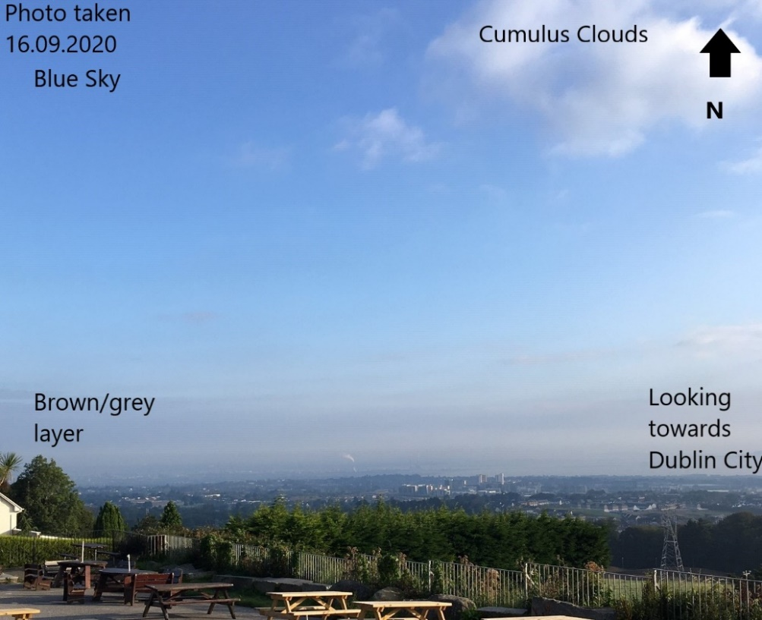
Smog - Particles that we can observe – typically larger PM
This photo was taken on a calm day when visibility was limited at lower levels in the sky.
- Note the bright blue sky at higher levels
- Note the brown layer above Dublin City
- We are observing particulate matter or aerosols in the sky
- What causes the colour change?

The term smog was typically used to describe a combination of fog and smoke – smog. The day the photograph above was taken, there was low-lying fog in this coastal area and there was little to no wind. Fog is an accumulation of low-lying water droplets, typically found near salt-laden water bodies, in this case, the Irish Sea. The fog over Dublin City is brown-grey in colour, this was due to urban air pollution combining with fog. The urban air pollution is due to fuel combustion from homes, traffic, and industry. Smog is most likely to occur on days when there is very little wind to disperse air pollution.

Met Eireann measures particles in the air at Valentia Island, Kerry using an Aerosol Optical Depth monitor, you can find out more here.

Particulate matter (PM) can form in one part of the world and travel many kilometres via wind currents to effect air quality in a different part of the world. We see this on a large scale during volcanic eruptions, forest wildfires and sandstorms.
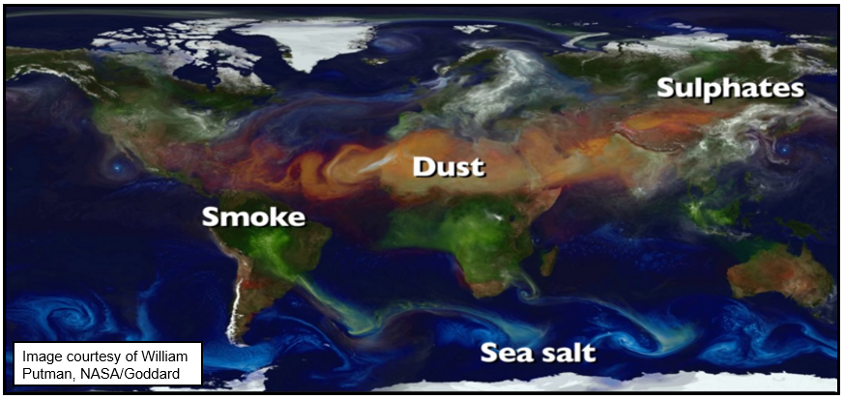
This image, courtesy of NASA, shows a variety of Particulate Matter/aerosols emitted across the globe and how what may seem like very local air quality problems can, in fact, travel across the world to have large impacts on far-away places.
The WHO and EU have set guideline values for particulate matter. Although there is no recognised safe level, the guidelines define upper limits. The WHO guidelines for PM are stricter when compared to EU Directive guidelines.

Fine particulate matter (PM2.5) 10 μg/m³ annual mean (EU directive states 25 μg/m³)
25 μg/m³ daily mean

Coarse particulate matter (PM10) 20 μg/m³ annual mean (EU directive states 40 μg/m³)
50 μg/m³ daily mean

- Pollutant Gases
The main outdoor pollutant gases are nitrogen oxides (NO_{x}), carbon monoxide, carbon dioxide (CO, CO₂), sulphur dioxide (SO₂), and ground-level ozone (O₃).
Nitrogen oxides (NOx) - is colourless and is oxidised in the atmosphere to form nitrogen dioxide (NO₂). Nitrogen dioxide is brown to red in colour and has a distinctive odour.
Carbon monoxide (CO)- a colourless, odourless, tasteless, and toxic gas that is produced during incomplete combustion of carbon-containing fuels, such as petrol/diesel, natural gas, oil, coal, and wood.
Sulphur Dioxide (SO₂) - a colourless, bad-smelling, toxic gas, and is part of a larger group of chemicals referred to as sulphur oxides (SOx).
Volatile organic compounds (VOCs) – these are typically human-made compounds used in manufacturing that turn to vapour (gas) at low temperatures.
Ground-level ozone (O₃) - is a colourless and highly irritating gas that forms just above the earth's surface. It is called a "secondary" pollutant because it is produced when two primary pollutants react in sunlight and stagnant air. These two primary pollutants are nitrogen oxides (NOx) and volatile organic compounds (VOCs). Take a look at this US EPA educational resource on ozone.

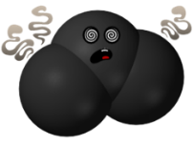
The GLOBE Air Quality Campaign measures NO_{2,} a traffic-related gaseous pollutant, at schools in Ireland. NO₂ originates from vehicle exhaust emissions and the highest levels of NO₂ are found closest to busy roads.
Nitrogen dioxide is not usually released directly into the air. Nitrogen dioxide forms when nitrogen oxide (NO) and other nitrogen oxides (NO_{x}) react with other chemicals in the air (for example, oxygen) to form nitrogen dioxide.
NO₂ is an important trace (small amounts found) gas in the atmosphere. It is harmful to our health and the environment, it is a ‘greenhouse gas’ which can affect our climate, it can reduce visibility, and it plays a role in determining ozone concentrations in the troposphere (WHO).
The WHO and EU Directive have set guidelines around NO₂ levels in the air, these are based on short-term hourly exposure and longer-term, annual, exposure.

NO₂ annual mean 40 μg/m³
hourly mean 200 μg/m³
Schools participating in the GLOBE Air Quality campaign have been measuring NO₂ for the past 2 years. The figure below shows the results of past campaigns in 2019 and 2020, for most schools, NO₂ (compared to annual mean) values were categorised as ‘pretty good’ (20 – 25 µg/m³) to ‘excellent’ (less than 10 µg/m³). These values are well below the threshold nitrogen dioxide guidelines issued by the World Health Organization (WHO) and the European Union (EU). However, unsurprisingly, schools located in cities and suburbs of cities, close to busy roads, recorded higher NO₂ levels compared to schools located in small towns and rural settings.
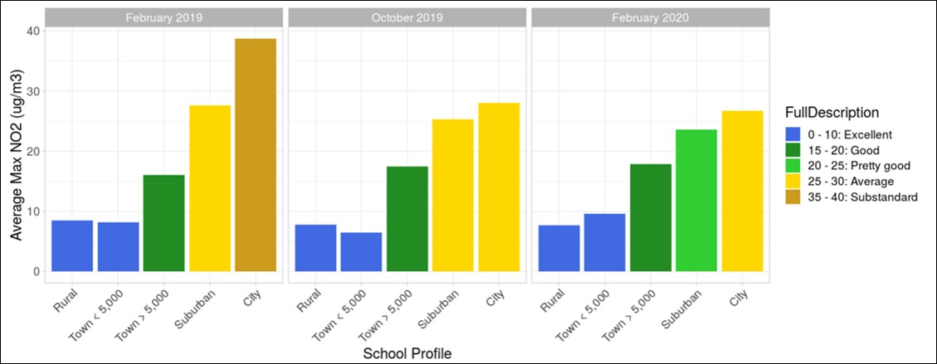

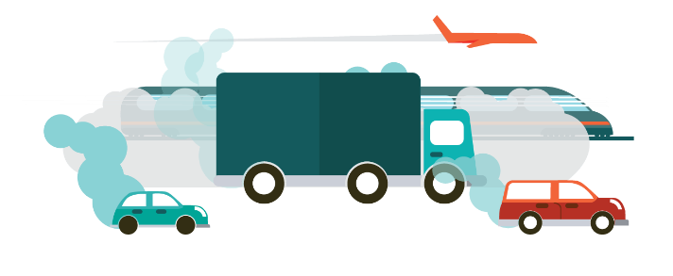
The GLOBE Air Quality results show that NO₂ pollution is a particular problem in heavily populated urban areas. In fact, a recent report from the Irish EPA states “Our findings (NO₂) represent an early warning of potential exceedances of EU limit values in Dublin – long-term exposure to these levels of NO₂ is a cause of concern for people’s health and action needs to be taken now to address these findings”.

Join GLOBE and measure Air Quality at your school!

Time for a short outdoor activity on sky visibility!
Encourage students to make observations about their local air quality! How is visibility at your school?

Sky visibility is an indication of the amount of the aerosols/particulate matter close to the surface of the ground. The more aerosols there are, the hazier it will appear. Pick a landmark in the distance and choose the most appropriate description below.

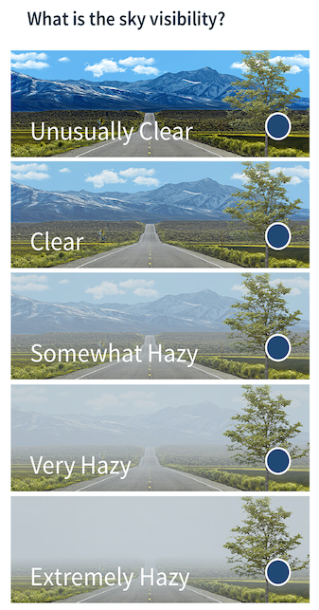

Unusually clear o

Clear o

Somewhat Hazy o

Very Hazy o

Extremely Hazy o

How do we know if the air we are breathing is clean or not?
The first step in understanding our air quality, is measuring pollutants, and assessing safe values for each pollutant. According to the Irish Environmental Protection Agency (EPA), the ambient air quality pollutants of most concern on an EU-wide level are nitrogen dioxide, particulate matter (PM), ozone and PAHs. Monitoring is carried out to determine their concentration levels.

- Nitrogen dioxide (NO₂) is a gaseous air pollutant that has a distinctive reddish/brown colour and an unpleasant smell. In Ireland, it mainly originates from transport (vehicle exhaust emissions), electricity power generation and industry. It has become a significant concern in urban areas where high levels have been measured close to busy roads.

- Particulate Matter (PM) as discussed above, is particles of solid or liquid material suspended in the air. PM in Ireland originates from solid fuel burning, transport (diesel vehicle emissions) and agriculture. Ammonia emitted by farming activities reacts in the atmosphere with other chemicals to also produce particulate matter. In Ireland, in some regions, levels for both PM₁₀ and PM_{2.5} are above the WHO air quality guideline values.

- Polycyclic Aromatic Hydrocarbons (PAHs) PAHs are organic compounds predominantly originating from solid fuel burning, particularly wood burning and, to a lesser extent, vehicle emissions.

- Ground Level Ozone (O₃) Ground level ozone (O₃) refers to the ozone gas found close to the ground, not to be confused with the ozone found at much higher elevations in the atmosphere forming part of the ozone layer. Ground level ozone is bad for our health whereas the ozone layer, high in the atmosphere, protects us from harmful radiation.

- Why do we care about air pollution?
The European Environment Agency has identified air pollution as the single largest environmental health hazard in Europe, accounting for over 1,180 premature deaths each year in Ireland.

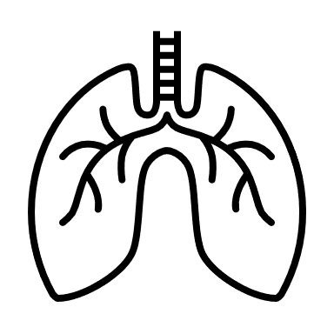
Breathing is an instinct; we take approximately 17,000 to 23,000 breaths every single day without thinking too much about it!
  - Our lungs filter thousands of litres of air every day

  - Try holding your breath for 1 minute, how does it feel?
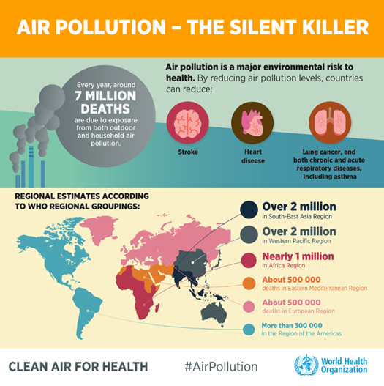
We want to be healthy – how does air pollution effect our health?
Air pollution has a big impact on our health and the environment around us.
According to the European Environmental Agency air pollution is a major cause of premature death and disease and is the single largest environmental health risk in Europe.
Heart disease and stroke are the most common reasons for premature death attributable to air pollution, followed by lung diseases and lung cancer.

This image, produces by the Scottish EPA, highlights the main pollutants of concern and the associated effects on our bodies, see here for more information.

Who is affected by air pollution?
Some population groups are more affected by air pollution than others, because they are more exposed or more vulnerable to environmental hazards. The following groups are particularly susceptible to air pollution
- Lower socio-economic groups tend to be more exposed to air pollution
- Older people
- Children
- Those with pre-existing health conditions

Air Pollution and Covid-19
Read the following article in the Cork Echo Live newspaper article, it is based on an interview with Professor John Sodeau from University College Cork who is an expert in air pollution.

Professor John Sodeau raises the question about the current covid-19 pandemic and air quality. It has been suggested that people living in areas where air pollution is a serious problem are more susceptible to having severe cases of covid-19.

Student Questions
Who should protect those who are more vulnerable?
How do we reduce air pollution as a community?

- What can we do about it?

On a global and regional scale, institutes like the World Health Organisation and regional unions, such as the European Union set out guidelines and pollutant thresholds to guide government bodies. Individual countries must take responsibility for the quality of their own country’s air, this includes understanding the current air quality condition through monitoring and enforcing guidelines as set by the World Health Organisation (WHO) and the European Union (for EU Member States). Governments must also consider their contribution of harmful pollutants in a global sense, as pollutants do not obey country boundaries.

Ireland’s EPA Air Quality Monitoring

In Ireland, the EPA monitors our air at a number of permanent monitoring stations, see http://www.epa.ie/air/quality/data/. The results of the monitoring are evaluated with respect to health http://www.epa.ie/air/quality/index/.

The Environmental Protection Agency’s Air Quality Index for Health (AQIH) is a number from one to 10 that tells you what the air quality currently is in the station nearest you and whether or not this might affect the health of you or your child. A reading of 10 means the air quality is very poor and a reading of one to three inclusive means that the air quality is good. The AQIH map updates every two to five minutes with the most up-to-date calculated
Air Quality Index for Health (AQIH) for each station.

In Ireland, our network of EPA monitoring stations does a great job assessing the quality of our air but there are not enough monitoring stations to assess air quality everywhere and at local levels.

This is especially true when it comes to pollutants that vary their concentrations over 100s of meters from the source, such as nitrogen dioxide (NO₂).

The schools that take part in the GLOBE Air Quality Campaign are measuring local air quality at their school.
The results of the GLOBE Air Quality Campaign are shared with the EPA, which provides the EPA Air Quality team with more information about local air quality.

EPA colour-coded Air Quality Scale

How can we strive for clean air?

What can individuals and school community groups do?

- Participate in the school-based GLOBE Air Quality Campaign
- Raise Awareness – by educating people they will make more informed decisions and vote for change

- Encourage No-Idling - many people do not switch their engine off while their car is stopped. This can happen quite a bit outside school! Can you create posters for your school walls or school gates discouraging idling?

- Encourage Active-Transport – more walk-to-school days or other forms of active travel would reduce local traffic-related air pollution

- Plant More Trees – Trees and plants can help filter the air, trapping some pollutants on leaves and needles

Become an active citizen and promote clean air activities!

Student research questions

Here are some questions students could investigate:

- What effect do wildfires have on air quality? Investigate recent wildfire events in the Western US States or Australia and examine the impact of the fires on community health.
- What effects do long-term exposure (10s of years) of low to moderate air quality have on health?
- How do we communicate the risks associated with air pollution to communities? How can I inform my school community?
- How does agricultural practices influence air pollution? Should people and communities in rural settings care about air pollution?

Here are two more interesting articles:

https://www.bbc.com/future/article/20200427-how-air-pollution-exacerbates-covid-19

https://www.thejournal.ie/readme/air-pollution-5156739-Jul2020/

