Activity: Draw a map of your school
Purpose: Guide decision making on where to locate NO₂ Diffusion Tubes
Educational Outcomes: Encourages observational skills, spatial awareness, map reading, technical drawing to scale
Curriculum links: Links to Junior Cycle Science, Geography, and fundamental earth & environmental science skill
Tools required:
- If drawing by-hand - Pencil, paper, and ruler and area map
- If using a computer - Microsoft Word (or other software to create a simple map)

Additional tools: Access to a computer to use Google Maps (satellite view) or Google Earth. Local maps or aerial photographs
Supporting documents: Air Pollution factsheet, Air Pollution and Weather factsheet and the GLOBE ‘Making a Map’ resource

ACQ2_Mapping Exercise – Plan your Air Quality Campaign
Introduction
You will be receiving your tubes for measuring nitrogen dioxide, a traffic-related pollutant, shortly. Your job is to decide where on the school grounds/surroundings to mount those tubes. This is a really important step in designing your study. How do you decide where to put your tubes?

Drawing a map of your study area (school) is part of the scientific process, focusing on
- Observations
- Asking Questions
- Developing Hypotheses
- Planning your Investigation

Map drawing is a skill that is often used in Earth and Environmental science investigations.
Stage 1. Planning
Take a few minutes to discuss the purpose of the map and ask students what should be included in the map.
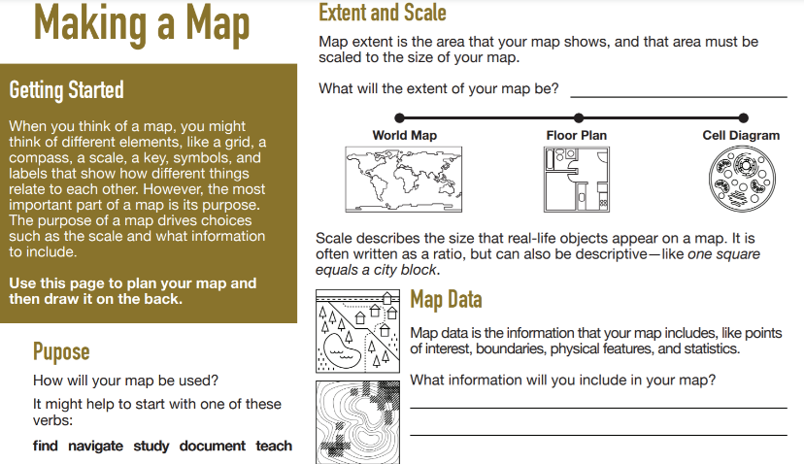
- What is the purpose of the map?
- What kind of information should I include?
- What area should I cover?

Feel free to use the GLOBE ‘Making a Map’ resource.

Stage 2. Hand-draw your map!
- Keep your map simple!
- Draw from ‘birds eye view’ perspective (looking down)
- Label north using an arrow
- Draw the outline of the major buildings, outdoor playing areas (yard, field/pitches), and nearby roads
- Clearly label any car parks, drop off/pick up areas, traffic ‘pinch points’ where cars tend to idle (entrance gates, traffic lights)
- Use a paper OSI topographic map or Google Maps to measure the distance between nearby roads and your school. Alternatively, you can ‘pace’ the distance on foot (do not forget to measure your stride length first!)
- Mark where you think the diffusion tubes should be positioned on your map
- Complete your legend

OR

Stage 2. Create a digital map!

- You could Microsoft Word (or any software where you can draw/insert simple shapes)
- Keep your map simple!
- Draw from ‘birds eye view’ perspective
- Label north using an arrow
- Draw the outline of the major buildings, outdoor playing areas (yard, field/pitches), and nearby roads
- Clearly label any car parks, drop off/pick up areas, traffic ‘pinch points’ where cars tend to idle (entrance gates, traffic lights)
- Use a paper OSI topographic map or Google Maps to measure the distance between nearby roads and your school. Alternatively, you can ‘pace’ the distance on foot (do not forget to measure your stride length first!)
- Mark where you think the diffusion tubes should be positioned on your map
- Complete your legend

Stage 3. Now you have created a map, what next?
Once you have drawn your map, you can try to predict areas where nitrogen dioxide (NO₂) gas is likely to be higher, such as, close to a busy road or drop off point (idling cars), and conversely where nitrogen dioxide is likely to be lower.
For example, look at the sketch map (not to scale) below. Where you would place your diffusion tubes at this school?
Legend here

What kind of information are you looking for?
We suggest choosing a location where NO₂ is likely to be high, for instance close to a main road, a place where NO₂ is likely to be moderate, for instance at a drop-off point or school car park, and a place where NO₂ is likely to be low, for instance in an area away from traffic.
Every school is different! We can make predictions but sometimes we are wrong – this is why we are testing our hypothesis by monitoring NO₂ over a period of time.
If you have taken part in the AQ campaign before, perhaps you wish to place a tube in the same location to compare your results from year to year, or perhaps you wish to test a new area?

What else will affect my results?
- The prevailing wind direction will influence the movement of nitrogen dioxide! NO₂ levels are highly variable and can decrease just 10s of meters away from their source.
- Is the air flow pattern moving nitrogen dioxide from a nearby road towards your school? You can look up historical wind direction to identify your local prevailing wind direction when choosing locations.
- It is also a good idea to record the daily weather during the measurement period too.

Student Presentations

Ask students to present their final map to the class. The objective is to reach a class decision on where to locate the monitoring tubes. Students could include supporting information, such as prevailing wind direction, likely traffic pinch-points, school commute routes, to decide where the tubes should be mounted.

